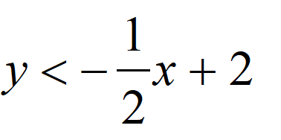  $$↓↓↓↓↓↓↓↓↓↓Fold 1↓↓↓↓↓↓↓↓↓$$ | 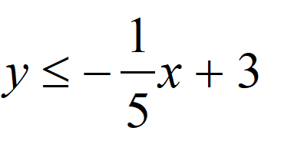  $$↓↓↓↓↓↓↓↓↓↓Fold 1↓↓↓↓↓↓↓↓↓$$
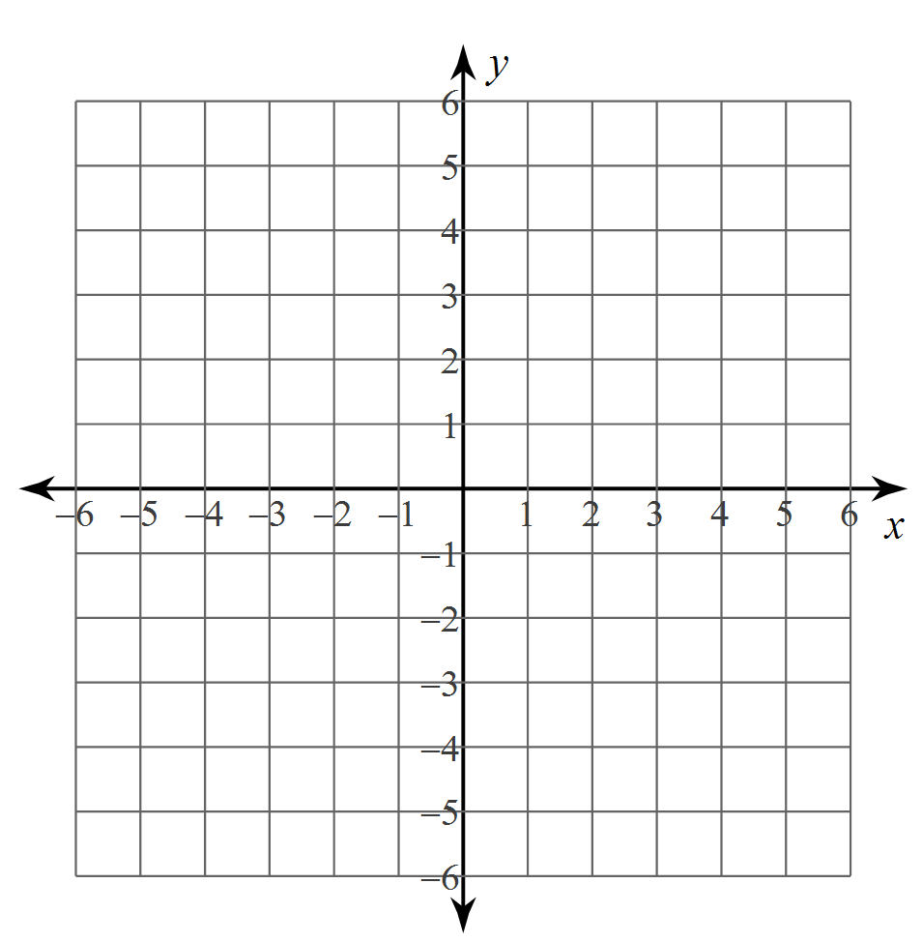  $$↓↓↓↓↓↓↓↓↓↓Fold 2↓↓↓↓↓↓↓↓↓$$ | $$↓↓↓↓↓↓↓↓↓↓Fold 2↓↓↓↓↓↓↓↓↓$$
$$↓↓↓↓↓↓↓↓↓↓Fold 3↓↓↓↓↓↓↓↓↓$$ | $$↓↓↓↓↓↓↓↓↓↓Fold 3↓↓↓↓↓↓↓↓↓$$
  Equation:
  Equation:
$$↓↓↓↓↓↓↓↓↓↓Fold 4↓↓↓↓↓↓↓↓↓$$ | $$↓↓↓↓↓↓↓↓↓↓Fold 4↓↓↓↓↓↓↓↓↓$$
$$↓↓↓↓↓↓↓↓↓↓Fold 5↓↓↓↓↓↓↓↓↓$$ | $$↓↓↓↓↓↓↓↓↓↓Fold 5↓↓↓↓↓↓↓↓↓$$
  Equation:
  Equation:
  Equation:
  Equation:

